General Information
- The registration process for this competition is separate from other region competitions. Please follow the steps outlined in this document: CSI Registration.
- 15 teams will advance to the State Leadership and Skills Conference.
- The proctor cannot be the SkillsUSA Georgia advisor. This must be a non SkillsUSA/ACCT, Public Safety or Cosmetology related individual.
- The proctors will receive instructions on how exactly the props/room should be set up on the Zoom meeting.

Knowledge Performance
There will be a multiple choice knowledge assessment.
- The contest will include a written knowledge test assessing knowledge of crime scene photography, physical evidence, legal issues, procedures, crime scene sketches, fingerprinting and releasing a crime scene. The test will have 15 questions.
- Each team member will take the assessment independently.
- The test will be given during the Zoom call. A link will be shared and there will be 15 minutes for the team to complete the test. Teams should already be logged into a computer/Chromebook with internet access when the Zoom call starts. They need to be in view of the Zoom call area - testing on the Equipment Tables (see diagram below)

Skill Performance
The contest will include activities that simulate situations encountered by crime scene investigators.

Note: the school, advisor and competitor are responsible for providing supplies and equipment needed.

Contest Guidelines
Room Set Up - the area must be clear and have nothing in the way of the competitor. Ideally it should be a classroom with a large open space - at least 8x10. The room should have tables to set the CSI equipment enabling the equipment to be accessed easily. Other equipment is listed below.

Recording - each part of the live contest will require a Point of View (POV) camera set to view the entire competition area. The POV camera must be stationary, and set on a tripod, table, or any other stable mount. A laptop, IPad, or smartphone with a webcam may suffice. Any webcam will need internet access and must be able to connect to the Zoom Meeting. Be sure the webcam is fully charged and plugged-in.

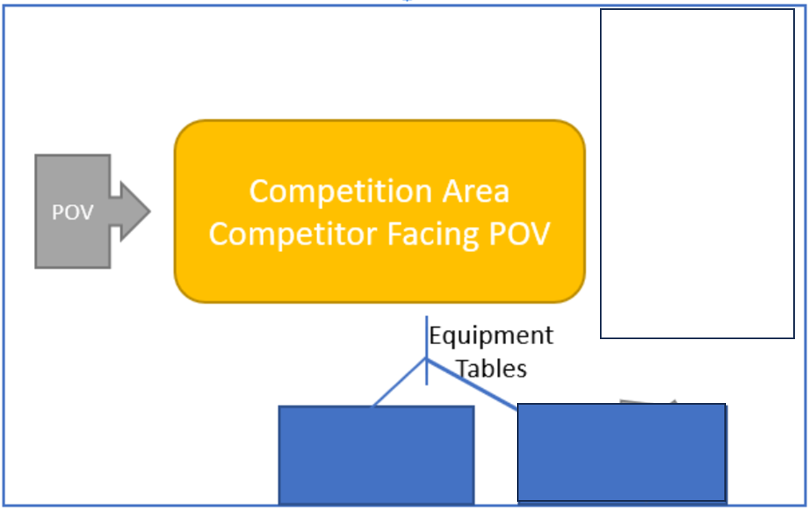
Preparation
- POV is ready, plugged-in and online, able to connect to Zoom
- POV operator - may be advisor
- Access to a computer with internet and with word processing
  - The camera needs to be able to send photographs to the internet for uploading to a share drive. A SD card and reader are probably the best options.
  - It is the schools’ responsibility to make sure the school’s network will allow for uploading to the share drive.
- At a minimum each team and/or team member should have the following items to process their scene:
  - Digital Camera
    - Be sure to set resolution to a lower setting (150-300K) or be able to reduce photo size on a computer.
  - PPE to include shoe covers and gloves (Tyvek not needed)
  - Latent print examination kit/fingerprint kit
  - Measuring device (laser measuring device or tape measure)
  - Scale (preferably an ‘L’ shaped scale, but tape measure will work if ‘L’ scale is unavailable)
  - Sterile swabs and swab boxes
  - Distilled water
  - Evidence placards/markers/cones
  - Evidence bags; paper and plastic
  - Tamper proof evidence tape
  - Sharpie
  - Graph paper and pencil for sketch/measurements
  - Tweezers
  - Lift tape
  - Paperwork - logs, reports, etc.
  - Color printer access
NOTE - All equipment must be ready and accessible at the START of the Zoom call.
- Props - may or may not be used, but must be available during Zoom call. Take the time to collect these prior to the Zoom call. Items MUST match the descriptions below!
  - Masking tape
  - Clothing
    - Cotton t-shirt
    - Mixed blend or all synthetic athletic shorts
    - Socks - any type
    - Cotton hoodie or sweatshirt
    - Athletic shoes
  - Drinking glasses
  - Bottles - plastic or glass
  - 4 plates - dinner size
  - 4 set of silverware - spoon, fork, knife - plastic is fine
  - Apple or pear - fresh
  - Corn syrup - 4+ ounces
  - Cocoa powder - small amount, 2+ tablespoons
  - Pet fur - dog or cat
  - Regular student backpack with normal student items
  - Hotel key card - or ID, plastic card or similar to hotel key card
  - Shell casings - handgun, any caliber
  - Fake knife - cut cardboard or ruler with taped end are fine
  - Fake gun - water pistol or cut cardboard are fine
  - Pens -
    - Sharpie - any color
    - Ink pens - any color
    - Non-permanent markers (i.e., Crayola) - any color
  - Carpet - actual floor or 6in x 6in (or larger) sample piece
  - Ziplock sandwich bag with white powder - tablespoon of flour, sugar, etc.
  - Furniture items
    - 4 Chairs - school type or folding are fine
    - Trash Can - with trash (end of school day type stuff)
    - Table - about 3 ft x 3 ft - card table sized or similar

Live Competition Elements:
At NO POINT can an advisor assist the competitor in any way.

A proctor must be a non SkillsUSA/ACCT, Public Safety or Cosmetology related individual.

Competitors will be assigned a Zoom time. The team must be present and ready to start. All items must be ready as specified. It is imperative all devices are plugged-in - not relying on its battery. Proctors must be with the team and ready to set up things as needed.

Note - if at the Zoom start time the CSI team is not present and/or the competition area is not set up the Zoom meeting will stop and the team will be disqualified.

The scoring process will take the volunteer judges over 25 hours to meet with and record all of the CSI teams. Be considerate of the judges’ time.

The following procedures will be followed during the competition:

- First, the CSI team will take a CSI Knowledge Assessment Exam. This will be monitored on Zoom.
  - 15 minutes.
- Second, the CSI team will have one member collect/process an item of evidence. The demonstration will be recorded via Zoom for later judging.
  - The Proctor will need to set the evidence while the team is out of the room.
  - The evidence will be handled by the single team member in front of the POV camera.
  - The other team members may watch, but not assist or coach.
  - 10 minutes.
- Third, the CSI team will process a crime scene. This process will be recorded via Zoom for later judging.
  - The Proctor will set up a crime scene while the team is out of the room.
  - The CSI team will return and document the scene via photographs, sketching, and notes. The CSI team will identify and document evidence, but they will not collect it.
  - 15 minutes (plus additional set up time for the Proctor)
.
- Last, after the Zoom meeting the CSI team will have one hour to upload their sketch, photographs, and reports to the share drive link provided. Additional items might be requested for upload - such as any photographs of the evidence taken during the second stage of the contest.
  - The team can receive no assistance during this process. The advisor may observe but cannot assist, coach or provide support.
  - The team may not consult any materials, website, or other type of assistance during this time.
  - We expect advisors and/or monitors to understand the impact that allowing cheating will have on their students. We expect professional integrity to overwhelm any competitive desires.
Minutiae
- CSI teams must be in full compliance of uniform requirements as specified by Nationals.
- CSI teams should have all equipment designated in the National contest standards available.
- Contestants shall not mention their name, school, city or state.
- Basic safety practices related to the skills performed must be followed.

