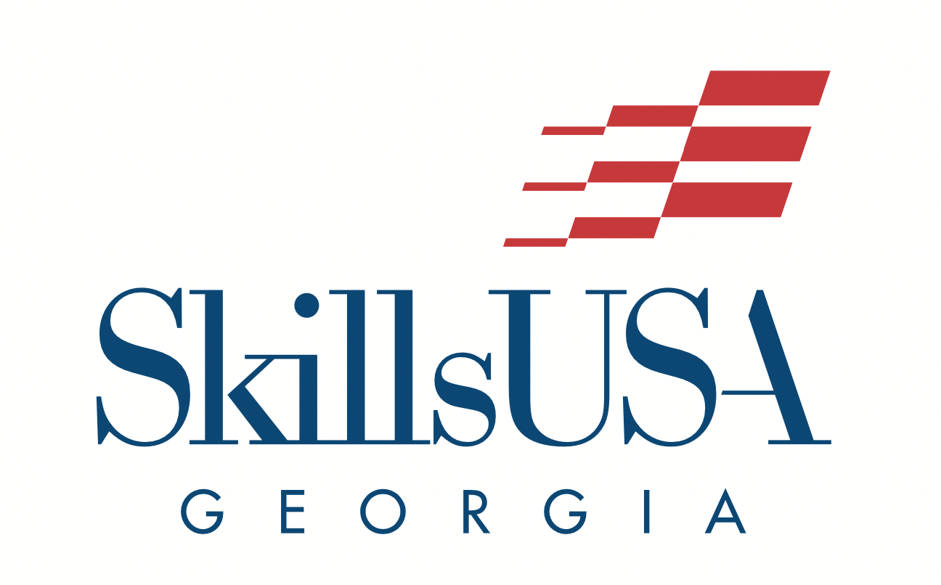

Region Championships Checklist
Last updated 10/9/2023.

Note: All deadlines are in red.

COMPLETED | ITEM | LINK | DESCRIPTION
 | Review the Region Championships Details Document | Check the Region Championships website for the most updated version:  Region Championships Details Document | This document includes Region Championships details such as:  - Dates/Deadlines  - Cost of Region Championships  - Required Forms
 | Check out the Region-Specific Updates section |  | When you click into your region, you’ll find region-specific information. Check back frequently!
 | Review the competition offerings | Region Championships
 | Explore the “Unique Region Championship Opportunities”  - Skills Challenges  - Crime Scene Investigation | Region Championships | The chart showcases the following information:  - Contest  - Contest Note  - Registration Method  - Region/State Qualifier
 | Explore the Skills Challenges webpage | Skills Challenges | The competitions held through the Skills Challenges include:  - Carpentry  - Electrical Construction Wiring  - Masonry  - Plumbing  - TeamWorks  - Welding
 | Review the Crime Scene Investigation competition details. | Crime Scene Investigation | This is a new region contest and will NOT be held at the technical college. Please be sure to review the details carefully.
 | Review the “Downloads” Section | Region Championships Downloads | Pay close attention to the Required Forms
COMPLETED | ITEM | LINK | DESCRIPTION
 | Review your region’s registration deadlines | Registration Deadline | Add the following deadlines to your calendar:  - Registration Deadline  - Payment Deadline  - Inclement Weather Deadline
 | Register student competitors through SkillsUSA Register | SkillsUSA Register | Choose your region in the drop-down menu under the “Conference” tab
 | Student Supervision Verification Upload Form Deadline | Student Supervision Verification Upload Form Deadline | The deadline to upload this form is your region’s registration deadline
 | Download, Print, and Provide the Registration, Personal, and Liability Release Form to student members. | Registration, Personal, and Liability Release Form | You will not submit this form, but you will keep it in your possession and bring it with you to Region Championships.
 | Complete the Proctor Form | Blank Proctor Form | Do this for any competitions that have an online testing component, or if your students are competing in the Crime Scene Investigation competition
 | Upload the Proctor Form | Upload Proctor Form | The deadline to upload the proctor form is December 8, 2023.
 | Make note of the competitions with an Online Testing Date component. You can also read about Online Testing in the Region Championships Details Document | - Region Championships  - Region Championships Details Document | There are two options for online testing:  January 9, 2024, OR January 11, 2024
COMPLETED | ITEM | LINK | DESCRIPTION
 | Consider the Wild Card Testing option for your competitors. Read about Wild Card Testing in the Region Championships Details Document. | Region Championships Details Document | There are two options for online testing:  January 9, 2024, OR January 11, 2024
 | Secure transportation for Region Championships. |  | Do this prior to your Region Championship date.
 | You will receive your invoice 48 hours after region registration closes. Work to secure payment (credit card or check) by the Payment Deadline. |  | Pay the Region Registration fee prior to the Region Championships deadline.
 | If your competitors are competing in the Broadcast News Production competition, write the following deadlines on your calendar. | The Broadcast News production upload link will go live on the Region Championships webpage on January 1, 2024. | - Broadcast New Production Prompt will be released on January 1, 2024.  - Broadcast News Production Project submission deadline: January 11, 2024, by 5:00 pm
 | Every competition requires a typed resume from the competitor. | Resume Tips | Day of Region Championships
COMPLETED | ITEM | LINK | DESCRIPTION
 | Winners will be announced on the dates listed in the “Description” column. |  | Wild Card Test Winners: January 22, 2024  The top scores will fill empty slots. The number will vary contest to contest.  ​  Broadcast News Production: January 22, 2024  The top 16 teams from across the state will advance to SLSC.  ​  Welding Fabrication: January 16, 2024  The top 8 teams from across the state will advance to SLSC.  TeamWorks: January 16, 2024  The top 10 teams from across the state will advance to SLSC.

